Challenge / Project

Final Objective
WHAT TO DO?
Explore image processing often used in object tracking.

HOW SHOULD IT WORK?
Go through the assignment materials and solve the intermediate tasks.

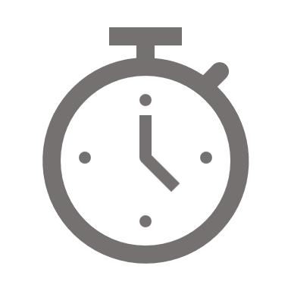





Required knowledge
Introduction to image processing in Object Tracking
1 hour
1

Activity 1: IMAGE PROCESSING IN OBJECT TRACKING
2

Image resizing
30 min
Task 1
Image cropping
1 hour
Task 2
Color conversion
30 min
Task 3
Image normalization
1 hour
Task 4

Required knowledge

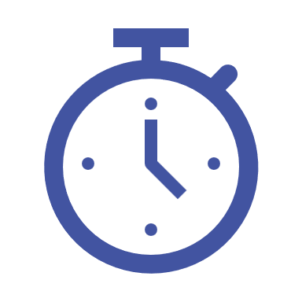

Required knowledge to be introduced to students
1 HOUR

In object tracking, image processing techniques are needed to ensure accurate and effective object tracking. Among these techniques, image normalization, resizing, and cropping play significant roles in preprocessing the visual data for enhanced tracking performance.
Image normalization standardizes pixel values to mitigate lighting variations, making images consistent and improving object recognition and tracking precision. Resizing can make different images’ dimensions equal, making it easier to apply tracking algorithms. Cropping isolates and concentrates on regions of interest, reducing computational workload and minimizing the probability of mistakes from irrelevant background details.
Together, these image-processing methods contribute to the robust tracking of objects within video.

In this code, we embark on our journey into object tracking. Our primary focus will be on methods for video display and the dynamic drawing of bounding boxes around objects throughout a sequence. Additionally, we will delve into essential image processing techniques frequently employed in object tracking. These techniques encompass resizing, cropping, color conversion, and image normalization.

Image Processing Techniques
To enhance our tracking skills, we explore various image processing techniques:

Resizing: Adjusting the image size; is critical for optimizing object tracking.
Advantages:
- Improved Performance: Smaller images require less computational power, enhancing performance.
- Data Reduction: Smaller images occupy less storage space.
Disadvantages:
- Loss of Detail: Scaling down images can lead to losing fine details.
- Aspect Ratio Concerns: Resizing can distort the original aspect ratio of an image.

Cropping: Extracting specific image portions to focus on the object of interest.
Advantages:
- Selective Focus: Cropping allows you to isolate and focus on specific regions of interest.
- Enhanced Clarity: Removing irrelevant content can make the remaining object more prominent.
Disadvantages:
- Loss of Context: Cropping may remove contextual information.
- Potential Information Loss: Important details outside the cropped area may be lost.

Color Conversion: Altering image colors for more detailed analysis.
Advantages:
- Enhanced Analysis: Changing colors can make certain object features more distinguishable.
- Compatibility: Converting images to a common color space aids in consistent processing.
Disadvantages:
- Loss of Color Information: Some color conversions may result in information loss.
- Subjectivity: Choosing the right color space may be subjective and dependent on the specific application.

Image Normalization: Standardizing image appearance for accurate tracking.
Advantages:
- Standardized Data: Normalization ensures uniformity in image data.
- Improved Object Detection: Minimizes variations in lighting and contrast.
Disadvantages:
- Application Specific: Normalization techniques need to be tailored to the application.

Activities


ACTIVITY 1: FUNDAMENTALS OF OBJECT TRACKING

TASK 1



Image resizing
1 H 30



Students´ work:

In this task, your goal is to engage in image resizing and explore different image dimensions.

Hint: To accomplish this, you can utilize the cv2.resize function, which is a useful tool for adjusting the size of an image.



Teacher’s solution

# Define the new dimensions of the image
new_width = 512
new_height = 512

# Resize the image to the new dimensions
resized_img = cv2.resize(img, (new_width, new_height))

# Display the original and resized images side by side
fig, axs = plt.subplots(1, 2) # Create a figure with one row and two columns
axs[0].imshow(img)
axs[0].set_title('Original Image')
axs[1].imshow(resized_img)
axs[1].set_title('Resized Image')
# Add a title to the figure
fig.suptitle('Comparison of Original and Resized Image')
# Show the figure
plt.show()

TASK 2



Image cropping
1 H 30



Students´ work:

For this task, your aim is to explore image cropping and experiment with various coordinates to define the Region of Interest (ROI) within an image.

Hint: You can utilize the cv2.imread function to read and obtain the image as a Numpy array, allowing you to employ numpy slicing techniques for extracting the Region of Interest (ROI) from the image.



Teacher’s solution

# Define the coordinates of the top left point of the ROI
top_left_x = 500
top_left_y = 1500
# Define the coordinates of the bottom right point of the ROI
bottom_right_x = 4000
bottom_right_y = 7000

# Extract the ROI from the image
cropped_img = img[top_left_y:bottom_right_y, top_left_x:bottom_right_x]

# Display the original and cropped images side by side
fig, axs = plt.subplots(1, 2) # Create a figure with one row and two columns
axs[0].imshow(img)
axs[0].set_title('Original Image')
axs[1].imshow(cropped_img)
axs[1].set_title('Cropped Image')
# add a title to the figure
fig.suptitle('Comparison of Original and Cropped Image')
# show the figure
plt.show()

TASK 3



Color conversion
1 H 30



Students´ work:

In this task, your goal is to conduct color conversion, specifically, converting the color space of an image from RGB to grayscale.

Hint: To accomplish this, you can employ the cv2.cvtColor function, which is a valuable tool for handling such conversions.



Teacher’s solution

# Convert the image to grayscale.
img_gray = cv2.cvtColor(img, cv2.COLOR_RGB2GRAY)
# Display the original and grayscale images side by side
fig, axs = plt.subplots(1, 2) # Create a figure with one row and two columns
axs[0].imshow(img)
axs[0].set_title("RGB Image")
axs[1].imshow(img_gray, cmap="gray")
axs[1].set_title("Grayscale Image")
# add a title to the figure
fig.suptitle("Comparison of RGB and Grayscale Image")
# show the figure
plt.show()

TASK 4



Image normalization
1 H 30



Students´ work:

For this task, your goal is to perform image normalization. This involves adjusting image values to fit within a specific range, and you will also experiment with different range intervals.

Hint: To achieve this, delve into the concept of min-max normalization and implement it. Pay close attention to [0, 1] normalization, as it holds significant importance in the field of computer vision.



Teacher’s solution

# Example: normalization to [0, 1] interval
normalized_img = img / 255

# Example: normalization to [0, 10] interval
min_val = np.min(img)
max_val = np.max(img)
normalized_img_to10 = 10 * ((img - min_val) / (max_val - min_val))

# Display the original and normalized images side by side
fig, axs = plt.subplots(1, 3) # Create a figure with one row and two columns

axs[0].imshow(img)
axs[0].set_title('Original Image', fontsize=8)
axs[1].imshow(normalized_img)
axs[1].set_title('Normalized Image to 0-1', fontsize=8)
axs[2].imshow(normalized_img_to10)
axs[2].set_title('Normalized Image to 0-10', fontsize=8)

# change x and y ticks size
for ax in axs:
ax.tick_params(axis='x', labelsize=8)
ax.tick_params(axis='y', labelsize=8)

# add a title to the figure
fig.suptitle('Comparison of Original and Normalized Images')

# apply tight layout of subplots
fig.tight_layout()
# show the figure
plt.show()

